**GOVERNMENT DEGREE COLLEGE, GUMMALAKSHMIPURAM**

**DEPARTMENT OF BOTANY 2024**

**Name of the Event: World Soil Day**

**Guest of Honor : Dr. T. Sreevaram (Principal)**

**Date                : 05-12-2024**

**Department         : Botany**

**Lecturers Attended: 10**

**Students Attended: 50**

**The Department of Botany Government Degree college Gummalakshmipuram Conducted World Soil Day The Chief Guest Dr.T.Sreevaram Principal of the College Delivered a Message World Soil Day [WSD] is Celebrated annually On December 05 the to Highlight The Importance of Healthy Soil and Promote Sustainable management of Soil Resources . The Theme for This Year’s World Soil day 2024 ‘CARING FOR SOIL –MEASURE, MONITAR AND MANAGE.’**

**The event showed the Positive Impact on the Student.**

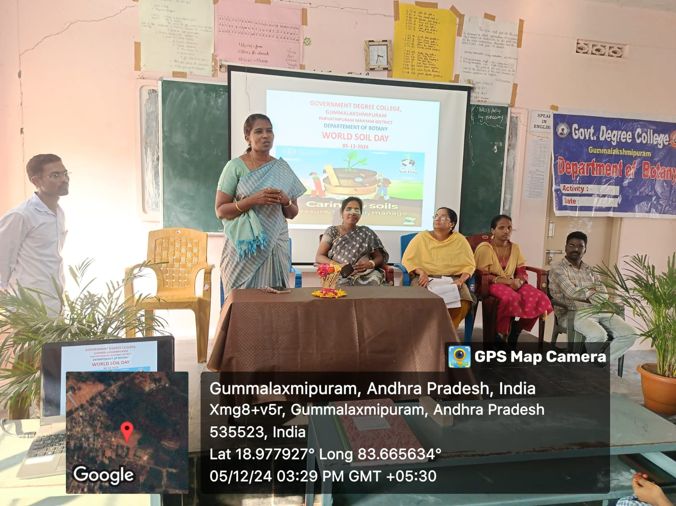

**Addressed by Dr. T. Sreevaram (Principal):**

**Good morning everyone It is my pleasure to stand before you today as we gather to celebrate World Soil Day 2024. This day serves as a vital reminder of the importance of soil in our lives. The theme for this year, "Soil and Water: A Source of Life", emphasizes the inseparable link between soil health and water quality, both of which are fundamental to sustaining life on Earth.**

**Soil is not merely dirt beneath our feet; it is a living, breathing ecosystem that supports plant growth, filters water, and stores carbon. Without healthy soil, we cannot grow the food we rely on, maintain clean water supplies, or combat the challenges of climate change. It is a resource that takes hundreds of years to form, yet can be degraded in a short span of time due to unsustainable practices.**

**As educators and students, we have a responsibility to understand and protect this precious resource. Simple actions like reducing waste, composting, planting trees and supporting sustainable farming can significantly contribute to soil conservation.**

**On this World Soil Day, let us pledge to be mindful of our actions and their impact on the environment. Let us work together to create a future where our soils remain healthy and fertile for generations to come. World Soil Day 2024 (WSD) campaign, under the theme Caring for soils: measure, monitor, manage underscores the importance of accurate soil data and information in understanding soils characteristics and supporting informed decision-making on sustainable soil management for food security.**

**Speech given by T. Satyarao Guest Faculty in Botany**

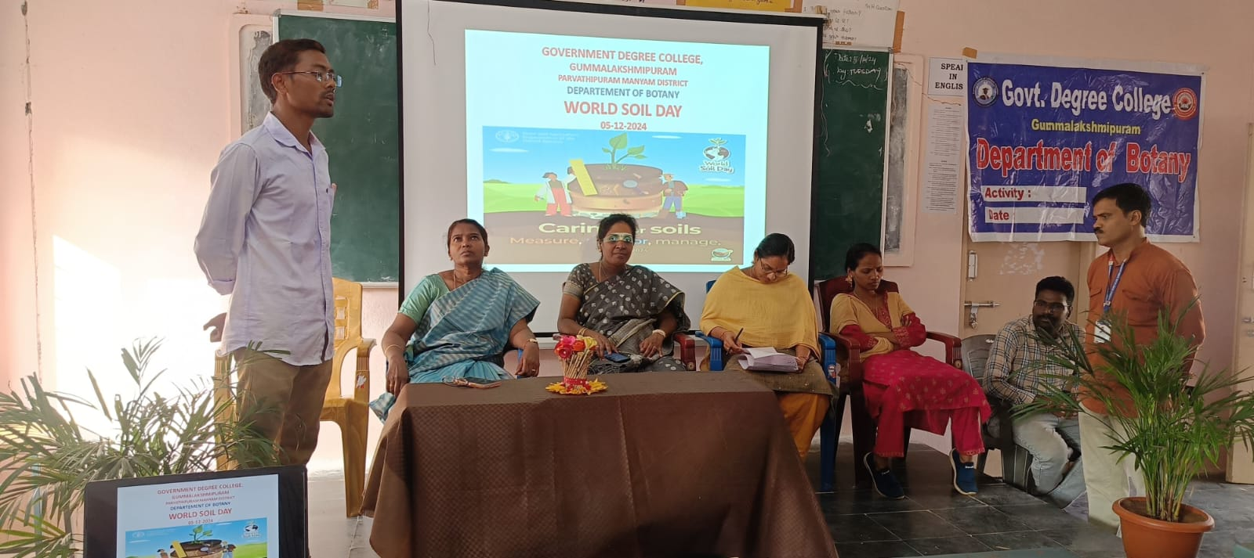

**Good morning everyone,**

**It is an honor to stand before you today on the occasion of World Soil Day 2024. As a student of botany and a passionate advocate for plant sciences, I believe it is crucial that we acknowledge and celebrate the invaluable role of soil in sustaining life on Earth.**

**This year’s theme, "Soil and Water: A Source of Life", highlights the intricate relationship between soil and water — two fundamental components that nourish ecosystems, support agriculture, and regulate the environment. Healthy soil acts as a natural sponge, filtering water, storing nutrients, and fostering plant growth. Without it, our food systems would collapse, and biodiversity would suffer immensely.**

**From a botanical perspective, soil is not merely a medium for plant growth. It is a dynamic, living ecosystem, teeming with microorganisms, fungi, and invertebrates that drive nutrient cycles. Plants, in turn, contribute to soil health through their roots, which enhance soil structure and promote organic matter accumulation. This fascinating interdependence is a testament to the resilience and complexity of nature.**

**However, soil degradation caused by deforestation, overgrazing, pollution, and unsustainable agricultural practices threatens this delicate balance. As researchers, educators, and students, we have significant role in advocating for sustainable soil management. Embracing practices like crop rotation, organic farming, and soil conservation initiatives can restore and maintain soil health.**

**On this World Soil Day, let us renew our commitment to understanding, protecting, and restoring our soils. By doing so, we not only ensure food security and environmental health but also contribute to the fight against climate change. Thank you all for your attention, and may we continue to learn from and protect the precious soil beneath our feet. Thank you**

**Speech given by students N. Anusha & D.Meghana**

